# **How to see Sirius B**

The two stars, the main component and the companion, orbit each other at a distance of approximately 20 AU (about the same as the distance between the sun and Uranus). As a result, when observed from Earth, Sirius B appears to describe an ellipse around Sirius A, with a period of 50 years.

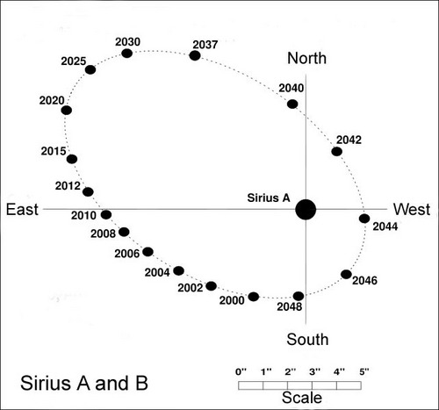

**We are in the years now of the greatest separation of Sirius A & B**

**Preparing to separate Sirius A & B**

A reflector telescope needs a clean mirror & well collimated.

Clean eyepieces.

Cool down telescope to outside temperature.

Important to do the observation with above average seeing.

Observe Sirius when high in the sky. (Best Months Jan. Feb)

**Okay, now go ahead and look for Sirius B**

Seeing is great, Sirius is high in the sky, the telescope is in perfect shape – now it’s time to look at Sirius, right?

Not so fast. Before that, take a look to the west (to the right) of Sirius, and observe the large constellation of Orion.

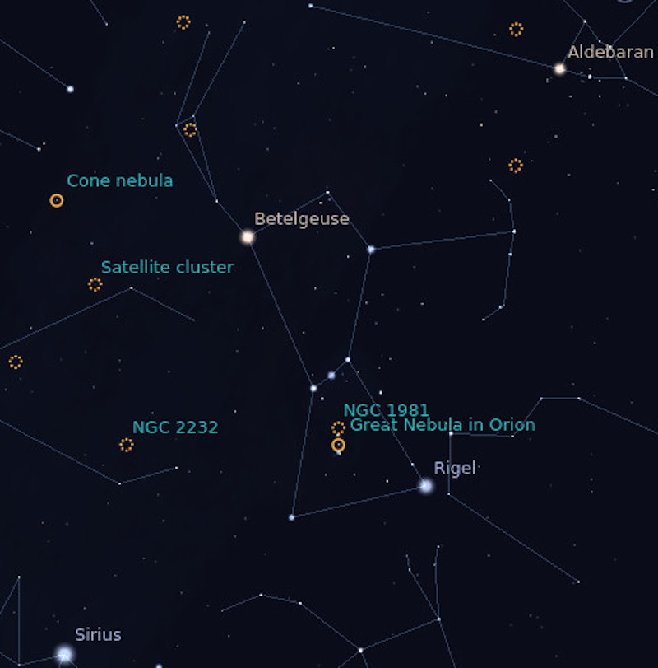Map of Orion. Image via [Florin Andrei](https://florin.myip.org/blog/how-see-sirius-b).

On the above map, Betelgeuse is on top, bright and red. In the middle, there’s the “belt” made of 3 stars. Then at the bottom there’s Rigel, a bright white star.

Rigel itself is a double star. The separation between Rigel A and B is similar to the separation between Sirius A and B. Except the brightness difference between Rigel A and B is much less than the difference between Sirius A and B, which makes Rigel a much easier double to split.

So grab a high power eyepiece, plug it into the scope, and point the instrument at Rigel. You’ll see a bright white star, and nearby a much smaller star, which is supposed to be white but looks quite yellow to me. Try to memorize the distance between Rigel A and B, because it’s similar to the current distance between Sirius A and B.

If you can’t see Rigel B, either seeing is so bad, or your scope is so out of whack, there’s no point to even try to see Sirius B.

### Time to actually describe the observation of Sirius B

You should use very high magnification. Forget what you’ve heard on forums or from word-of-mouth about “magnification limits”; just plug in a strong eyepiece. For a 150mm (6″) scope, 300x is not too much; for a 200mm (8″) scope, up to 400x; for a 300mm (12″) scope, up to 600x. Try the highest magnification available, then back off a little if things are too fuzzy. You should not use less than half the magnifications indicated above – in other words, for a 200mm (8″) scope, stay between 200x and 400x.

Point the scope at Sirius, turn off tracking (if your scope has it), and let the star drift across the field. Sirius B is currently close to due east from A (east-north-east), so it should be trailing the primary star, following the primary a little bit off to the side of A’s trajectory.

A comfortable chair helps you relax and breathe slowly. Keep looking at the primary star and be mindful of the surrounding area trailing the star as it drifts across the field. There will be a lot of light scattered from the primary, making it hard to see anything in the vicinity. Just relax and keep watching.

Sometimes the eye is covered in excess fluid (tears, basically) which blurs the image. Back off from the eyepiece a few millimeters and blink slowly and firmly a couple times (but don’t squeeze it shut too hard), then resume.

### How Sirius B appears

In theory, Sirius B should be just outside the bundle of shimmering brightness centered on Sirius A, but being pretty weak it’s hidden by the tremendous glare from the primary. Once in a while, something will coalesce out of nothing in that area, and you’ll see the unmistakable round pattern of a star.

Even in good seeing, it will wink in and out of existence. Or you’ll see it for a few moments, then it will vanish again for a long time. Do not confuse it with a diffraction or seeing artifact from the primary; stars are round, whereas artifacts are typically more linear or oddly-shaped.

Only when seeing is very good will you be able to see Sirius B for extended periods of time. Usually it’s more elusive than that.

When your eyes are tired, take a break, or observe the Great Orion Nebula nearby. Or look at Rigel A/B again and memorize the distance between them. Then get back to hunting Sirius B.

If this is the first time you’re attempting this observation, and you fail, well, that’s normal. Try again tomorrow. And again. It’s pretty hard to catch just the sort of perfect seeing required to see this star, so persistence is an important ingredient in the recipe. Perfect seeing, a telescope in perfect shape, high magnification, and persistence: that’s how it’s done.

Good luck, and clear skies.

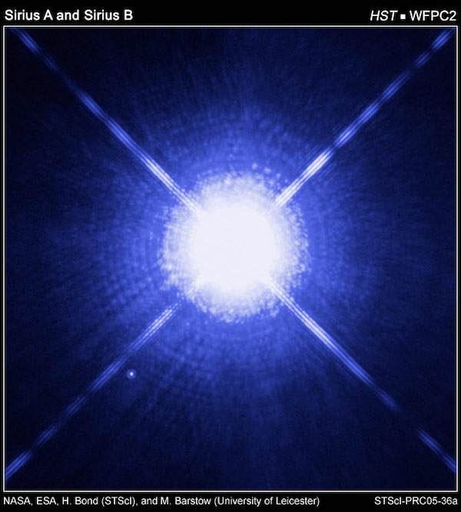This is how the Hubble Telescope sees Sirius A and B. The Pup is that tiny dot of light near the bottom-left spike. This makes it quite clear why Sirius B is so hard to see in ground-based telescopes. Image via [Hubblesite](https://hubblesite.org/image/1820/category/90-white-dwarfs" \t "_blank).

Bottom line: Sirius, the Dog Star, is a binary star, with a small white dwarf called the Pup orbiting the large primary star. The Pup isn’t easy to observe, but possible – and here’s how.

**4**

SHARES

**How to Obtain Your Double Star Sirius Certificate.**

Download the excel form from the members section of Our Website [www.rascmontreal.org/titan](http://www.rascmontreal.org/titan). Click members only. Login. Click on programs Go to the Double Stars section. Download the form Double Star Record Sirius.xlsx. Fill it out. Send it back via email to secretary@rascmontreal.org.